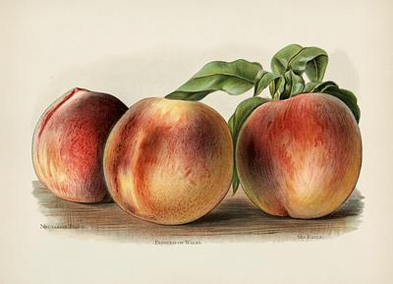
Avon Park Centennial Celebration
FRUIT COBBLER Amateur Baking Contest

REGISTRATION FORM

Name_____________________________________________________

Phone # ________________Email_______________________________

Address_________________________________________ Zip________

Division: _____ Age 5- 7 _______ Age 8-18 ______Adult

9 to 10:15 AM Drop off at the Avon Park Senior Activity Center
10:30 AM Judging Begins, please have items dropped off no later than 10:15
12:30 PM Winners will be announced from the Bandstand

Email registration form to: avonparkmainstreet@gmail.com
or
tiffanynsmith33@gmail.com

Registration forms may also be brought to the Avon Park Main Street office at 32 E. Main Street. Registration is requested prior to the event.

